Jeppe High School for Boys

Subject: Life Orientation
Mid-Year Examination
Grade: 10

Date: 06 June 2018
Duration: 1 ½ Hours
Total Marks: 80
Examiner: B. Riskowitz
Moderators: T. Janse van Rensburg / L. Hallett
QC Moderator: C. Rattray
Number of Pages: 8
________________________________
Instructions:
- Complete the front cover of your answer booklet.
- Answer all questions in the answer booklet provided.
- Answer all questions in Sections A and B.
- Answer 2 questions from Section C.
- Write your teacher’s name on the front cover.
- Number in the middle of the page.
- Write neatly and legibly.
- Rule off after each section.
- No borrowing.
- The following are not allowed in the examination room: cell phones, school bags, ipods (or similar devices), books, dictionaries, notes, sketches or paper.
Only the official examination material distributed by the invigilator is allowed.

SECTION A: 20 Marks

QUESTION 1: Multiple Choice
Various options are provided as possible answers to the following questions. Choose the most correct answer and write only the letter (A-D) next to the question numbers 1.1 – 1.10 in the answer book. E.g. 1.6 B

1.1 ……………. is the first step to discover who you really are.
- Self-awareness
- Self-esteem
- Self-development
- Self-confidence

1.2 The term bias means:
- dislike, fear or mistrust of someone.
- a fear and unfair preference of someone.
- unfair preference or dislike of someone.
- rules that are applied to different people.

1.3 Gender equality in the workplace is best fulfilled when:
- men and women have equal opportunity in the workplace.
- the behaviour of women is judged according to different standards.
- certain professions are exclusive to men.
- women are devalued and debased by society.

1.4 The term used to describe the roles, beliefs and expectations that people typically
associated with being male or female is:
- sexual identity.
- sexual orientation.
- gender stereotypes.
- gender roles.

1.5 Respiratory endurance is the ability:
- of the muscles to exert force during an activity.
- of the heart and lungs to supply oxygen to the muscles of the body.
- of the muscles to move for long periods of time and is an indicator of the muscles' ability to do the work.
- to move the muscles and joints through their full range of motion and is beneficial in injury prevention and relaxation.
[5]

QUESTION 2: Short Questions
Answer the following questions in full sentences, paying close attention to the mark allocations:
2.1 Explain the link between self-esteem and volunteering. (1X2) (2)
2.2 Explain in detail how understanding your own life domains will assist you
to choose a career. (2X2) (4)
2.3 What are “human rights”? (1)
2.4 “Human dignity” is a human right. State TWO (2) responsibilities any
human has to uphold this right. (2)
2.5 Explain the term “social justice”. (1) [10]

QUESTION 3: Definitions
Define the following terms:
3.1 xenophobia. (1)
3.2 equality. (1)
3.3 discrimination. (1)
3.4 stereotyping. (1)
3.5 life domains. (1) [5]
SECTION A: 20 MARKS
SECTION B: 30 Marks

QUESTION 4: Case Study
Analyse the image below and answer the questions that follow:
Source: Noah. 2017. https://www.facebook.com/1524768047547516/photos/a.1525688857455435.1073741828.1524768047547516/
1526479417376379/?type=3&theater
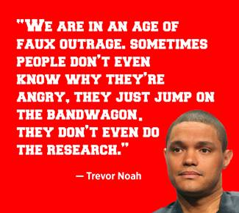
4.1 Critically analyse why people “just jump on the bandwagon [and] don’t
even do the research”. (2X2) (4)
4.2 Predict the possible dangers of this generation not doing “research” and
just following the crowds. (2X2) (4)
4.3 Determine two advantages of using social media for research. (2)
[10]
QUESTION 5: Scenario
Read the scenario below and answer the questions that follow:
Socio-economic factors can help or limit your development and progress. Phillip is a Grade 10 learner who lost both his parents to AIDS. He has been left with no real financial backing and no real means of transport. Phillip wishes to continue to study and work hard at school so as to qualify for university after Grade 12.
Anonymous

5.1 Based on the socio-economic factors governing Phillip’s life, critically
analyse his chances of furthering his studies. (2X2) (4)
5.2 Deduce TWO (2) means of funding Phillip could acquire for studying, and
show why he could qualify to receive these. (2X2) (4)
5.3 Distinguish what Phillip’s alternatives would be, should he not find
employment after his studies. (2)
[10]

QUESTION 6: Cartoon Analysis
Study the cartoon below and answer the questions that follow:
Source: Baram. 2018. http://www.essay.ws/the-gender-stereotype-essay/
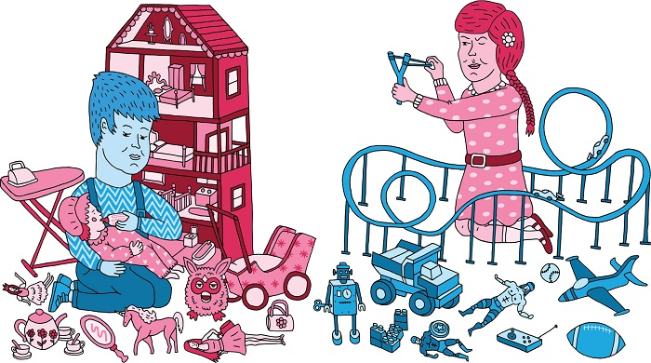

6.1 Contrast the images in the cartoon with the stereotypical “norms” that
have been placed on genders throughout history. (3+3) (6)
6.2 Critically analyse how the reversal of stereotypical gender roles (as seen
in the cartoon above) could assist in developing more equal power
relations in society. (2X2) (4)
[10]

SECTION B: 30 MARKS

SECTION C: 30 Marks
Only answer TWO (2) of the THREE (3) following questions. Please read all instructions as these can affect your marks to some extent.

QUESTION 7
Study the excerpt below and answer the question that follows:
Source: Sapa. 2013. https://www.enca.com/south-africa/mthethwa-says-sas-crime-linked-poverty
The fight against crime could not be separated from the war on poverty, Police Minister Nathi Mthethwa said on Thursday. The minister said contact crimes such as murder, rape and assault result in environments which do not allow for decent social and family life.
"Violence against women, children and the elderly is still prevalent in our society. This phenomenon results in preventing our country from creating a caring and humane society, underpinned by values of human solidarity, justice, peace and development."
People must also realise that with rights, come responsibilities. "The... negative impact is that the policing of public protests draws the police away from their normal policing activities and forces the police to redirect resources," Mthethwa said.

Construct an essay in which you:
7.1 Evaluate the relationship between crime and poverty.
7.2 Argue at least THREE (3) ways that crime and violence both have an effect on the
emotional state of an individual.
7.3 Defend the notion that there is a relationship between rights and responsibilities
by means of an example mentioned in the article, to substantiate your answer.
7.4 Conclude with THREE (3) ways to decrease crime and violence in our
communities?
[15]
AND/OR

QUESTION 8
Study the excerpt below and answer the question that follows:
Source: Luwes. 2018. https://www.iol.co.za/news/politics/choose-a-career-path-that-reflects-your-talents-and-interests-13601195
Choose a career path that reflects your talents and interests
One of the most daunting choices you’ll face in your last two or three years of school is deciding which career you’d like to pursue, and which tertiary qualifications will help you meet your goal. This is about finding the place where your passions, your abilities and the needs of the job market meet up.

Compose an essay that addresses the following:
8.1 Define the term “talent” and consider why career advisers would want to know about
your talents and interests.
8.2 Debate how the THREE (3) main life domains assist in the career decision-making
process.
8.3 Critically evaluate how an understanding of the following may aid in choosing a
career and ensure correct steps in the career decision-making process in grade 10:
a) personality type, skills and abilities.
b) career fields.
c) subject choices.
[15]
AND/OR

QUESTION 9
Study the excerpt below and answer the question that follows:
Source: CNBC Africa. 2016. https://www.cnbcafrica.com/news/southern-africa/2016/03/08/jse-rings-bell-for-gender-equality-in-africa/
JSE rings bell for gender equality in Africa
The Johannesburg Stock Exchange (JSE) celebrated International Women’s Day with a discussion on how far they have come and how other organisations need to have similar goals.
“The celebration is to let us hear that there’s something that needs to be done in the sector. As an organisation we’ve done extremely well. Seven out of ten people in the executive are women. 61 percent of our staff are women, so as the JSE we’ve done well,” said Zeona Jacobs, Director of Marketing and Corporate Affairs at the JSE. She continued to point out that other companies in the same industry are not doing as well. “If you look at the boards and executive positions of other financial services companies in South Africa, on the continent, as well as in the rest of the world you don’t see the same reflection of what’s happening at the JSE.”

Design a magazine article which engages the following:
9.1 Compare the following concepts: “gender equality”, “power” and “power relations”.
9.2 Critically evaluate why so few companies have as many women in powerful
positions as the JSE does?
9.3 Formulate THREE (3) strategies that can be implemented to change the attitudes
and behaviours which cause unequal power relations in society as a whole.
[15]

SECTION C: 30 MARKS
End of Paper
TOTAL: 80 MARKS

